**Name:** Mozeb Ahmed Khan

**Roll No:** 20F-0161

**Section:** BS (CS)-6A

**Course:** Web Programming

**Lab No:** 06+07 (jQuery)

**Task 1:**

Describe the method to use comments in HTML, CSS, and JavaScript with appropriate example.

**Explanation:**

1. An **HTML** comment is placed inside <body> element, and starts with <!—and ends with -->
2. A **CSS** comment is placed inside the <style> element, and starts with /* and ends with */
3. A **JavaScript** comment is placed inside the <script> element, and have two ways to write: One is by adding // at the line start (single-line) and second is placing the text between /* and */ (multi-line)

**Code:**

<html lang="en">

<head>

    <meta charset="UTF-8">

    <meta name="viewport" content="width=device-width, initial-scale=1.0">

    <title>Document</title>

    <style>

        #demo {

            text-align: center;

            /*This is a CSS comment*/

        }

    </style>

</head>

<body>

    <!--This is an HTML comment-->

    <p id="demo"></p>

</body>

<script>

    //This is a single-line JavaScript comment

    let text = "No Output as comments are hidden on a webpage.";

    document.getElementById("demo").innerHTML = text;

</script>

</html>

**Output:**

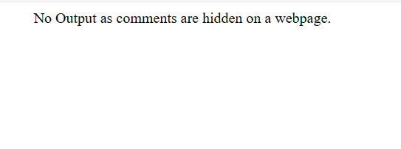

**Task 2:**

Show alert message “Welcome to jQuery” using both jQuery download and CDN method.

**1 - By Using jQuery Download**

**Code:**

<html lang="en">

<head>

    <meta charset="UTF-8">

    <meta name="viewport" content="width=device-width, initial-scale=1.0">

    <title>Document</title>

    <script src="jquery-3.7.1.min.js"></script>

</head>

<body>

    <script>

        $(document).ready(function(){

            alert("Welcome to jQuery");

        });

    </script>

</body>

</html>

**Output:**

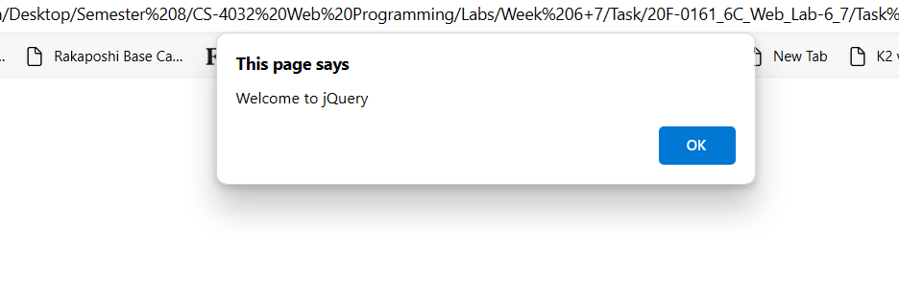

**2 - By Using CDN**

**Code:**

<html lang="en">

<head>

    <meta charset="UTF-8">

    <meta name="viewport" content="width=device-width, initial-scale=1.0">

    <title>Document</title>

    <script src="https://ajax.googleapis.com/ajax/libs/jquery/3.7.1/jquery.min.js"></script>

</head>

<body>

    <script>

        $(document).ready(function(){

            alert("Welcome to jQuery");

        });

    </script>

</body>

</html>

**Output:**

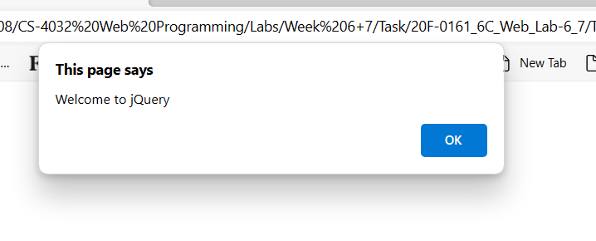

**Task 3:**

Upload image-using HTML in your webpage, create a button that toggle image display between show and hide using jQuery.

3.1 Button Text should also toggle.

3.2 Image should also toggle accordingly.

**Code:**

<html lang="en">

<head>

    <meta charset="UTF-8">

    <meta name="viewport" content="width=device-width, initial-scale=1.0">

    <title>Document</title>

    <script src="https://ajax.googleapis.com/ajax/libs/jquery/3.7.1/jquery.min.js"></script>

    <style>

        img {

            display: none;

        }

    </style>

</head>

<body>

    <img id="img1" src="https://www.gstatic.com/classroom/logo_square_rounded.svg" alt="Image">

    <button id="btn1">Show Image</button>

    <script>

        $(document).ready(function(){

            $("#btn1").click(function(){

                $("#img1").toggle();

                var buttonText = $(this).text();

                if (buttonText === "Show Image") {

                    $(this).text("Hide Image");

                }

                else

                {

                    $(this).text("Show Image");

                }

            });

        });

    </script>

</body>

</html>

**Output:**

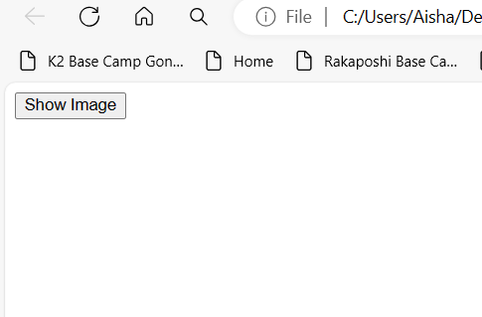

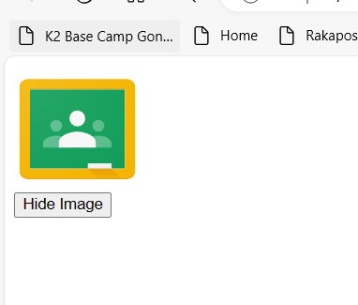

**Task 4:**

Write a program using jQuery to remove any Row of the table and also attach the screenshot.

**Code:**

<html lang="en">

<head>

    <meta charset="UTF-8">

    <meta name="viewport" content="width=device-width, initial-scale=1.0">

    <title>Document</title>

    <script src="https://ajax.googleapis.com/ajax/libs/jquery/3.7.1/jquery.min.js"></script>

</head>

<body>

    <table id="table1" border="1">

        <tr>

            <th>Course Code</th>

            <th>Course Name</th>

            <th>Course Instructor</th>

        </tr>

        <tr>

            <td>CS4032</td>

            <td>Web Programming</td>

            <td>Sumaira Mustafa</td>

        </tr>

        <tr>

            <td>AI2002</td>

            <td>Artificial Intelligence</td>

            <td>Mahzaib Younas</td>

        </tr>

        <tr>

            <td>CS4038</td>

            <td>Data Mining</td>

            <td>Ayesha Liaqat</td>

        </tr>

        <tr>

            <td>CS4044</td>

            <td>Fundamentals of Software Project Management</td>

            <td>Saba Naseem</td>

        </tr>

        <tr>

            <td>CS4046</td>

            <td>Game Design and Development</td>

            <td>Saba Ghani</td>

        </tr>

    </table>

    <br>

    <button id="btn1">Remove Row</button>

    <script>

        $(document).ready(function(){

            $("#btn1").click(function(){

                $("#table1 tr:last").remove();

            });

        });

    </script>

</body>

</html>

**Output:**

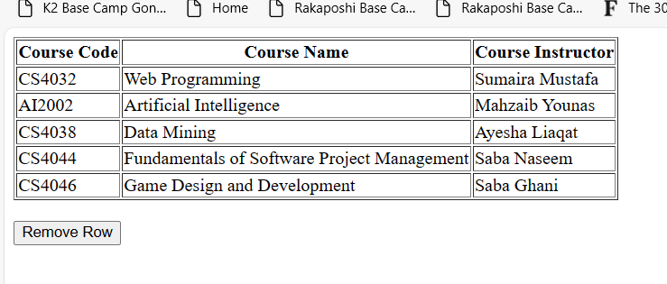

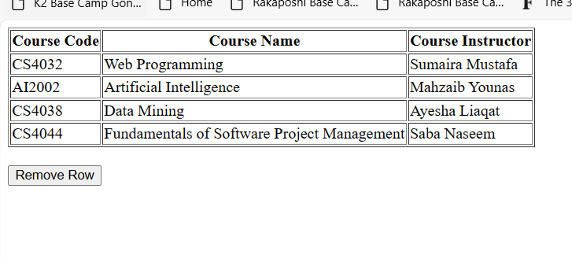

**Task 5:**

Write a program using jQuery to find the class and id of the clicked element. (Note: First develop the HTML page assign both classes and ids)

**Code:**

<html lang="en">

<head>

    <meta charset="UTF-8">

    <meta name="viewport" content="width=device-width, initial-scale=1.0">

    <title>Document</title>

    <script src="https://ajax.googleapis.com/ajax/libs/jquery/3.7.1/jquery.min.js"></script>

</head>

<body>

    <div>

        <h1 class="Large-Heading" id="h1">Heading 1</h1>

        <h2 class="Large-Heading" id="h2">Heading 2</h2>

        <h3 class="Large-Heading" id="h3">Heading 3</h3>

    </div>

    <div>

        <h4 class="Small-Heading" id="h4">Heading 4</h4>

        <h5 class="Small-Heading" id="h5">Heading 5</h5>

        <h6 class="Small-Heading" id="h6">Heading 6</h6>

    </div>

    <p id="demo"></p>

    <script>

        $(document).ready(function(){

            $(".Large-Heading").click(function(){

                let Class = $(this).attr("class");

                var Id = $(this).attr("id");

                text = "<b> Class: </b>" + Class + "<br>" + "<b> ID: </b>" + Id;

                document.getElementById("demo").innerHTML = text;

            });

        });

        $(document).ready(function(){

            $(".Small-Heading").click(function(){

                let Class = $(this).attr("class");

                var Id = $(this).attr("id");

                text = "<b> Class: </b>" + Class + "<br>" + "<b> ID: </b>" + Id;

                document.getElementById("demo").innerHTML = text;

            });

        });

    </script>

</body>

</html>

**Output:**

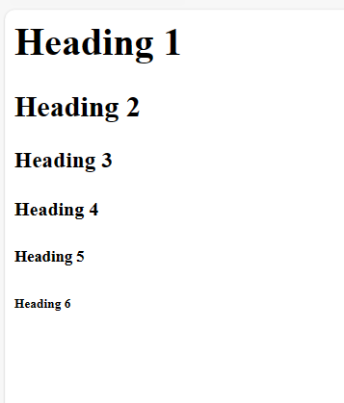

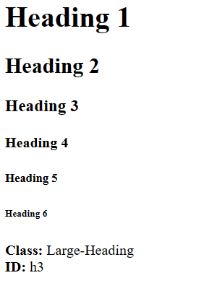

**Task 6:**

Find the total width of an element (including width, padding, and border) in jQuery. Consider the following code for HTML and CSS:

**Code:**

<!DOCTYPE html>

<html>

<head>

<script src="https://code.jquery.com/jquery-git.js"></script>

<meta charset="utf-8">

<meta name="viewport" content="width=device-width">

<title>Find total width of an element (including width, padding and

border) in jQuery.</title>

<style>

    p {

        padding-top: 50px;

        padding-right: 30px;

        padding-bottom: 50px;

        padding-left: 80px;

        border: 2px solid black;

    }

</style>

</head>

<body>

<p id="myText">jQuery Exercises, Practice, Solution</p>

<p id="demo"></p>

<script>

$(document).ready(function(){

    var totalWidth = $("#myText").outerWidth(true);

    text = "Total Width including padding and border: " + totalWidth + "px";

    var width = $("#myText").width();

    text += "<br> Width: " + width + "px";

    var padding = totalWidth - width;

    text += "<br> Padding: " + padding + "px";

    var border = totalWidth - $("#myText").innerWidth();

    text += "<br> Border: " + border + "px";

    document.getElementById("demo").innerHTML = text;

});

</script>

</body>

</html>

**Output:**

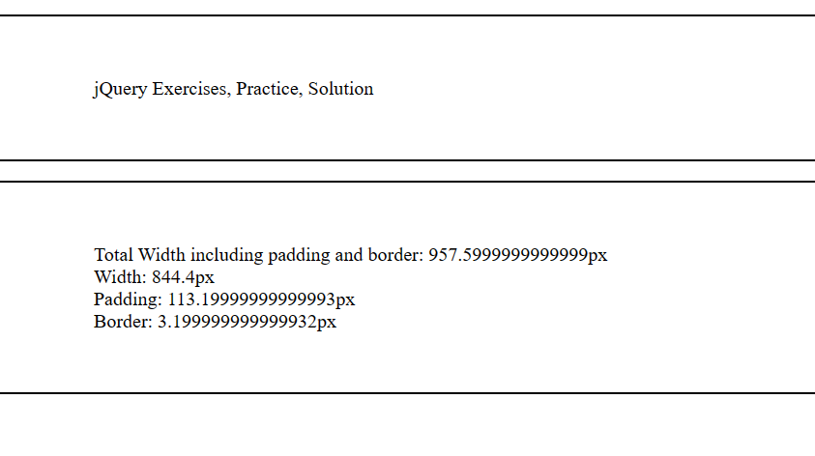

**Task 7:**

Write a program using jQuery to Count number of ‘p’ elements from the following:

**Code:**

<!DOCTYPE html>

<html>

<head>

<script src="https://code.jquery.com/jquery-git.js"></script>

<meta charset="utf-8">

<meta name="viewport" content="width=device-width">

<title>Count child elements using jQuery.</title>

</head>

<body>

<div id="selected">

<p>Red</p>

<p>White</p>

<p>Green</p>

<p>Black</p>

<p>Blue</p>

<p>Orange</p>

</div>

<p id="demo"></p>

<script>

$(document).ready(function(){

    var count = $("#selected p").length;

    document.getElementById("demo").innerHTML = "Number of 'p' elements: " + count;

});

</script>

</body>

</html>

**Output:**

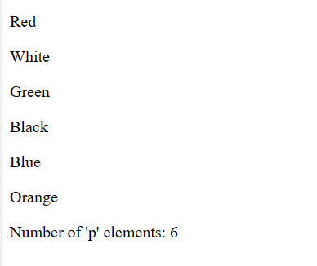

**Task 8:**

Perform animation on Div from left to right in 8sec duration using jQuery animate property.

**Code:**

<html lang="en">

<head>

    <meta charset="UTF-8">

    <meta name="viewport" content="width=device-width, initial-scale=1.0">

    <title>Document</title>

    <script src="https://code.jquery.com/jquery-git.js"></script>

    <style>

         #animatedDiv {

        width: 100px;

        height: 100px;

        background-color: red;

        position: absolute;

        top: 40%;

        left: 0;

    }

    </style>

</head>

<body>

    <div id="animatedDiv">HELLO</div>

    <script>

        $(document).ready(function(){

            var duration = 8000;

            var finalPosition = $(window).width() - $("#animatedDiv").width();

                $("#animatedDiv").animate({left: finalPosition}, duration);

                $("#animatedDiv").animate({fontSize: '20px'}, duration);

        });

    </script>

</body>

</html>

**Output:**

